renesas_an_blue

User’s Manual

User’s Manual

company

Rev.1.00 March 2017

All information contained in these materials, including products and product specifications, represents information on the product at the time of publication and is subject to change by Renesas Electronics Corp. without notice. Please review the latest information published by Renesas Electronics Corp. through various means, including the Renesas Electronics Corp. website (http://www.renesas.com).

Renesas Synergy™ Platform

Renesas Synergy™ Tools & Kits

Kits: S5D9 MCU

IoT Fast Prototyping Kit S5D9

User’s Manual

Notice

1. Descriptions of circuits, software and other related information in this document are provided only to illustrate the operation of semiconductor products and application examples. You are fully responsible for the incorporation or any other use of the circuits, software, and information in the design of your product or system. Renesas Electronics disclaims any and all liability for any losses and damages incurred by you or third parties arising from the use of these circuits, software, or information.

2. Renesas Electronics hereby expressly disclaims any warranties against and liability for infringement or any other disputes involving patents, copyrights, or other intellectual property rights of third parties, by or arising from the use of Renesas Electronics products or technical information described in this document, including but not limited to, the product data, drawing, chart, program, algorithm, application examples.

3. No license, express, implied or otherwise, is granted hereby under any patents, copyrights or other intellectual property rights of Renesas Electronics or others.

4. You shall not alter, modify, copy, or otherwise misappropriate any Renesas Electronics product, whether in whole or in part. Renesas Electronics disclaims any and all liability for any losses or damages incurred by you or third parties arising from such alteration, modification, copy or otherwise misappropriation of Renesas Electronics products.

5. Renesas Electronics products are classified according to the following two quality grades: "Standard" and "High Quality". The intended applications for each Renesas Electronics product depends on the product’s quality grade, as indicated below.

"Standard": Computers; office equipment; communications equipment; test and measurement equipment; audio and visual equipment; home electronic appliances; machine tools; personal electronic equipment; and industrial robots etc.

"High Quality": Transportation equipment (automobiles, trains, ships, etc.); traffic control (traffic lights); large-scale communication equipment; key financial terminal systems; safety control equipment; etc.

Renesas Electronics products are neither intended nor authorized for use in products or systems that may pose a direct threat to human life or bodily injury (artificial life support devices or systems, surgical implantations etc.), or may cause serious property damages (space and undersea repeaters; nuclear power control systems; aircraft control systems; key plant systems; military equipment; etc.). Renesas Electronics disclaims any and all liability for any damages or losses incurred by you or third parties arising from the use of any Renesas Electronics product for which the product is not intended by Renesas Electronics.

6. When using the Renesas Electronics products, refer to the latest product information (data sheets, user’s manuals, application notes, "General Notes for Handling and Using Semiconductor Devices" in the reliability handbook, etc.), and ensure that usage conditions are within the ranges specified by Renesas Electronics with respect to maximum ratings, operating power supply voltage range, heat radiation characteristics, installation, etc. Renesas Electronics disclaims any and all liability for any malfunctions or failure or accident arising out of the use of Renesas Electronics products beyond such specified ranges.

7. Although Renesas Electronics endeavors to improve the quality and reliability of Renesas Electronics products, semiconductor products have specific characteristics such as the occurrence of failure at a certain rate and malfunctions under certain use conditions. Further, Renesas Electronics products are not subject to radiation resistance design. Please ensure to implement safety measures to guard them against the possibility of bodily injury, injury or damage caused by fire, and social damage in the event of failure or malfunction of Renesas Electronics products, such as safety design for hardware and software including but not limited to redundancy, fire control and malfunction prevention, appropriate treatment for aging degradation or any other appropriate measures by your own responsibility as warranty for your products/system. Because the evaluation of microcomputer software alone is very difficult and not practical, please evaluate the safety of the final products or systems manufactured by you.

8. Please contact a Renesas Electronics sales office for details as to environmental matters such as the environmental compatibility of each Renesas Electronics product. Please investigate applicable laws and regulations that regulate the inclusion or use of controlled substances, including without limitation, the EU RoHS Directive carefully and sufficiently and use Renesas Electronics products in compliance with all these applicable laws and regulations. Renesas Electronics disclaims any and all liability for damages or losses occurring as a result of your noncompliance with applicable laws and regulations.

9. Renesas Electronics products and technologies shall not be used for or incorporated into any products or systems whose manufacture, use, or sale is prohibited under any applicable domestic or foreign laws or regulations. You shall not use Renesas Electronics products or technologies for (1) any purpose relating to the development, design, manufacture, use, stockpiling, etc., of weapons of mass destruction, such as nuclear weapons, chemical weapons, or biological weapons, or missiles (including unmanned aerial vehicles (UAVs)) for delivering such weapons, (2) any purpose relating to the development, design, manufacture, or use of conventional weapons, or (3) any other purpose of disturbing international peace and security, and you shall not sell, export, lease, transfer, or release Renesas Electronics products or technologies to any third party whether directly or indirectly with knowledge or reason to know that the third party or any other party will engage in the activities described above. When exporting, selling, transferring, etc., Renesas Electronics products or technologies, you shall comply with any applicable export control laws and regulations promulgated and administered by the governments of the countries asserting jurisdiction over the parties or transactions.

10. Please acknowledge and agree that you shall bear all the losses and damages which are incurred from the misuse or violation of the terms and conditions described in this document, including this notice, and hold Renesas Electronics harmless, if such misuse or violation results from your resale or making Renesas Electronics products available any third party.

11. This document shall not be reprinted, reproduced or duplicated in any form, in whole or in part, without prior written consent of Renesas Electronics.

12. Please contact a Renesas Electronics sales office if you have any questions regarding the information contained in this document or Renesas Electronics products.

(Note 1) "Renesas Electronics" as used in this document means Renesas Electronics Corporation and also includes its majority-owned subsidiaries.

(Note 2) "Renesas Electronics product(s)" means any product developed or manufactured by or for Renesas Electronics.

(Rev.3.0-1 November 2016)

**Renesas Synergy™ Prototyping Kit S5D9 Disclaimer**

By using this kit, the user accepts the following terms, which are in addition to, and control in the event of disagreement, with Renesas’ General Terms and Conditions available at https://www.renesas.com/en-us/legal/disclaimer.html.

The kit is not guaranteed to be error free, and the entire risk as to the results and performance of the kit is assumed by the User. The kit is provided by Renesas on an “as is” basis without warranty of any kind whether express or implied, including but not limited to the implied warranties of satisfactory quality, fitness for a particular purpose, title, and non-infringement of intellectual property rights with regard to the kit. Renesas expressly disclaims all such warranties.

Renesas does not consider the kit a finished product and therefore the kit may not yet comply with some requirements applicable to finished products, including, but not limited to recycling (WEEE), CE, UL, restricted substances (ROHS), FCC, FEE, and electromagnetic compatibility regulations. Renesas or its affiliates shall in no event be liable for any loss of profit, loss of data, loss of contract, loss of business, damage to reputation or goodwill, any economic loss, any reprogramming or recall costs (whether the foregoing losses are direct or indirect) nor shall Renesas or its affiliates be liable for any other direct or indirect special, incidental or consequential damages arising out of or in relation to the use of this kit, even if Renesas or its affiliates have been advised of the possibility of such damages.

Renesas has used reasonable care in preparing the information included in this document, but Renesas does not warrant that such information is error free nor does Renesas guarantee an exact match for every application or parameter to part numbers designated by other vendors listed herein. The information provided in this document is intended solely to enable the use of Renesas products. No express or implied license to any intellectual property right is granted by this document or in connection with the sale of Renesas products. Renesas reserves the right to make changes to specifications and product descriptions at any time without notice. Renesas assumes no liability for any damages incurred by you resulting from errors in or omissions from the information included herein. Renesas cannot verify, and assumes no liability for, the accuracy of information available on another company’s website.

**Precautions**

This Renesas Synergy™ Prototyping Kit is only intended for use in a laboratory environment under ambient temperature and humidity conditions. A safe separation distance should be used between this and any sensitive equipment. Its use outside the laboratory, classroom, study area, or similar such area invalidates conformity with the protection requirements of the Electromagnetic Compatibility Directive and could lead to prosecution.

The product generates, uses, and can radiate radio frequency energy and may cause harmful interference to radio communications. -There is no guarantee that interference will not occur in a particular installation. If this equipment causes harmful interference to radio or television reception, which can be determined by turning the equipment off or on, you are encouraged to try to correct the interference by one or more of the following measures:

• Ensure attached cables do not lie across the equipment.

• Reorient the receiving antenna.

• Increase the distance between the equipment and the receiver.

• Connect the equipment into an outlet on a circuit different from that which the receiver is connected.

• Power down the equipment when not in use.

• Consult the dealer or an experienced radio/TV technician for help.

Note: It is recommended that wherever possible shielded interface cables are used.

The product is potentially susceptible to certain EMC phenomena. To mitigate against them it is recommended that the following measures be undertaken:

• The user is advised that mobile phones should not be used within 10 m of the product when in use.

• The user is advised to take ESD precautions when handling the equipment.

The Renesas Synergy™ Prototyping Kit does not represent an ideal reference design for an end product and does not fulfill the regulatory standards for an end product.

Table of Contents

[1. Overview 6](#_Toc478131619)

[1.1 S5D9 MCU Board 6](#_Toc478131620)

[2. S5D9 IoT Fast Prototyping Kit Specification 8](#_Toc478131621)

[2.1.1 Electrical Specifications 8](#_Toc478131622)

[2.1.2 Connection Diagram 8](#_Toc478131623)

[3. S5D9 MCU Board Description 9](#_Toc478131624)

[3.1 Block Diagram 9](#_Toc478131625)

[3.2 Components Layout 10](#_Toc478131626)

[4. Power Supply 11](#_Toc478131627)

[5. PMOD and Grove Connectors 12](#_Toc478131628)

[6. USB Interface 14](#_Toc478131629)

[7. Digital Inputs and Outputs 15](#_Toc478131630)

[7.1 24V Tolerant Digital Inputs and Outputs 15](#_Toc478131631)

[7.2 On-Board LEDs 16](#_Toc478131632)

[8. Dual RS232 Interface 17](#_Toc478131633)

[9. JTAG Probe Interface 18](#_Toc478131634)

# Overview

The S5D9 IoT Fast Prototyping Kit features include the following interface options:

* RJ45 10/100Mbps Ethernet x1
* USB Full Speed x1
* PMOD x1
* Grove Connectors (UART, I2C, GPIO) x2
* Protected Digital Input x2
* Buffered Digital Output x2
* RS232 Transceiver x2
* JTAG Connector x1

The kit also includes the following on-board sensors:

* Bosch BMC 150 6-Axis sensor
* AMS ENS210 environmental sensor
* TE Connectivity MS5637-02BA03 barometric pressure sensor
* Knowles SPU0414HR5H-SB amplified SiSonic microphone

## S5D9 MCU Board

The S5D9 MCU Board is the heart of the IoT Fast Prototyping Kit. It enables the fast prototyping of applications that require wired Ethernet and USB connectivity along with PMOD and Grove expansion options.

The board includes 24V tolerant digital inputs with overvoltage protection suitable for use in noisy industrial environments. The board can also control two digital loads such as solenoids powered with 24V and drawing up to 1A current. The included MOSFET drivers have built-in overcurrent and over temperature protection that ensure robust operation.

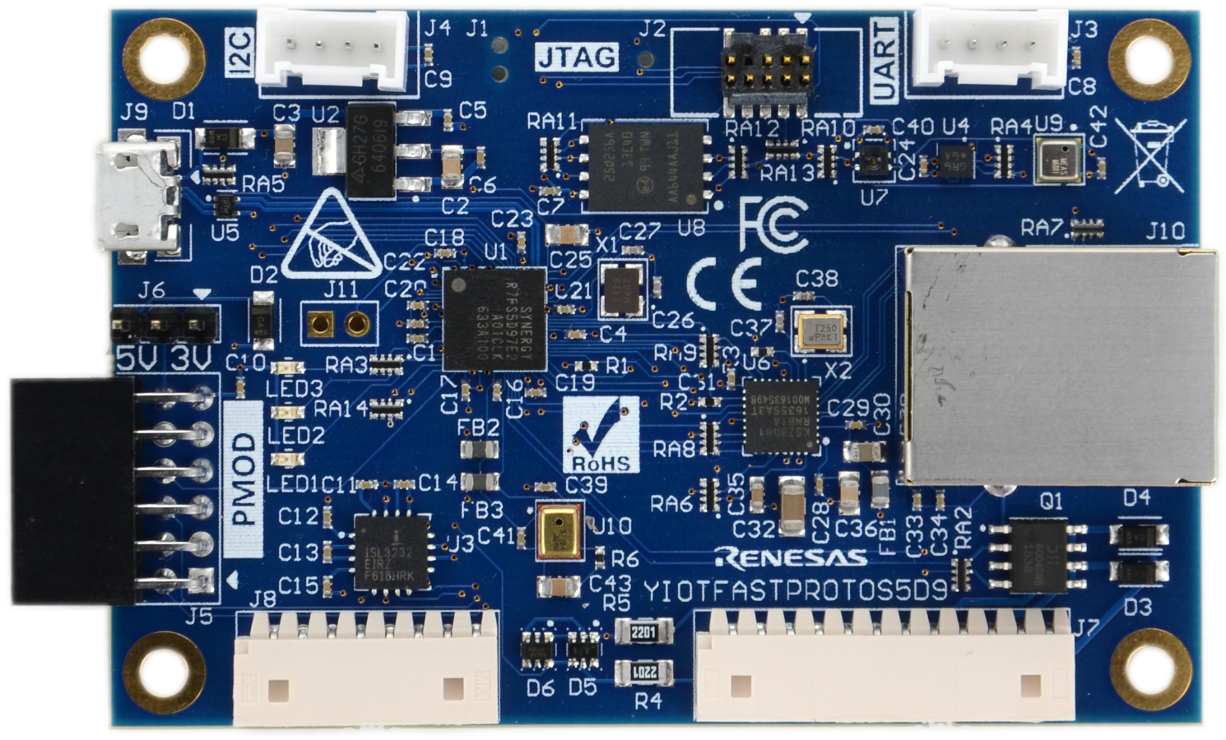

Figure 1.1 S5D9 MCU Board

The S5D9 board incorporates a Renesas Synergy Microcontroller with a 640K KB RAM and a 2 MB flash memory. In addition, the board has a 16 MB external flash memory connected through a QSPI interface.

The board can be powered using an industrial Molex connector, or through a USB device connector.

The board offers a variety of expansion options with one PMOD and 2 Grove connectors. The PMOD interface has designated jumper enabling the interface with either 3.3 V or 5 V powered modules.

The Grove connections consist of one UART interface and one I2C interface. The Grove connectors can power either 3.3V modules only.

The board also includes a JTAG interface for programming and debugging.

# S5D9 IoT Fast Prototyping Kit Specification

### Electrical Specifications

The S5D9 Fast Prototyping Kit specifications are listed in Table 2.1.

Table 2.1 Electrical Specifications

|  |  |  |
| --- | --- | --- |
| Parameter | Value | |
| Minimum | Maximum |
| Required Logic Power Voltage | 3.7V | 5.5V |
| Current Consumption | TBD | 300mA |
| Digital Outputs Drive Capability |  | 1A |
| Digital Inputs Voltage |  | 5.1 V or 24V |
| Operating Temperature | -40 °C | +75 °C |
| PMOD Connector Power Voltage | 3.3V | 5V |
| Grove Connectors Power Voltage | 3.3V | |
| QSPI Flash Capacity | 32 MB | |
| MCU Flash Capacity | 2MB | |
| MCU RAM | 640KB | |
| MCU Clock | 120MHz | |

### Connection Diagram

The IoT Fast Prototyping kit is intended to enable quick prototyping of various applications. Figure 2.1 shows the connection of components included in the kit for running the lab with the pre-installed firmware on the board or for designing new applications and downloading firmware over the JTAG interface.



Figure 2.1 Connection Diagram

# S5D9 MCU Board Description

## Block Diagram

The main functional blocks of the S5D9 board are presented in Figure 3.1.

UART & I2C Grove Connectors

12-pin PMOD

Connector

3x User-defined LEDs

2x 24V Tolerant Inputs and Outputs

32 MB SPI Flash

RJ45 Ethernet Interface

USB Device Interface

S5D9

Renesas Synergy MCU

JTAG Interface

Power Management:

3.3 V LDO

Figure 3.1 S5D9 board main functional blocks

The various modules are as follows:

* The Synergy MCU that is designated as the heart of the kit by the S5D9 block
* A power management module that includes 3V3 LDO voltage regulator required for the operation of the microcontroller.
* SPI Flash – the S5D9 flash memory is expanded with external 32 MB memory module connected over a high-speed QSPI interface. The external flash can be used for storage of graphics and other digital assets, or for execution of code in place (XIP).
* User-defined LEDs – the user-defined LEDs are useful in indicating the current state of the firmware. The 3 LEDs have different colors for easy identification.
* USB device interface – the S5D9 MCU includes one USB interface block operating in Full Speed. The USB device connector can be used to power the board.
* PMOD interface – the board includes one 12-pin PMOD interface that can be configured by jumpers to provide either 3.3V or 5V on their power pins. This feature expands the range of peripheral modules without the need for external level shifters or power supply.
* Grove interfaces – the Grove connectors are compatible with the Seeed Studio’s line of peripheral modules that feature a very large selection of sensors and actuators. One of the Grove connectors can be configured to communicate over the UART and the other is dedicated for I2C interface.
* JTAG interface that is available on a 10-pin connector, J20 compatible with Segger debugging probe. Alternatively, a 14-pin Tag-Connect interface probe can be used to program and debug the device.

## Components Layout

**Error! Reference source not found.** calls out the main components of the S5D9 MCU board.

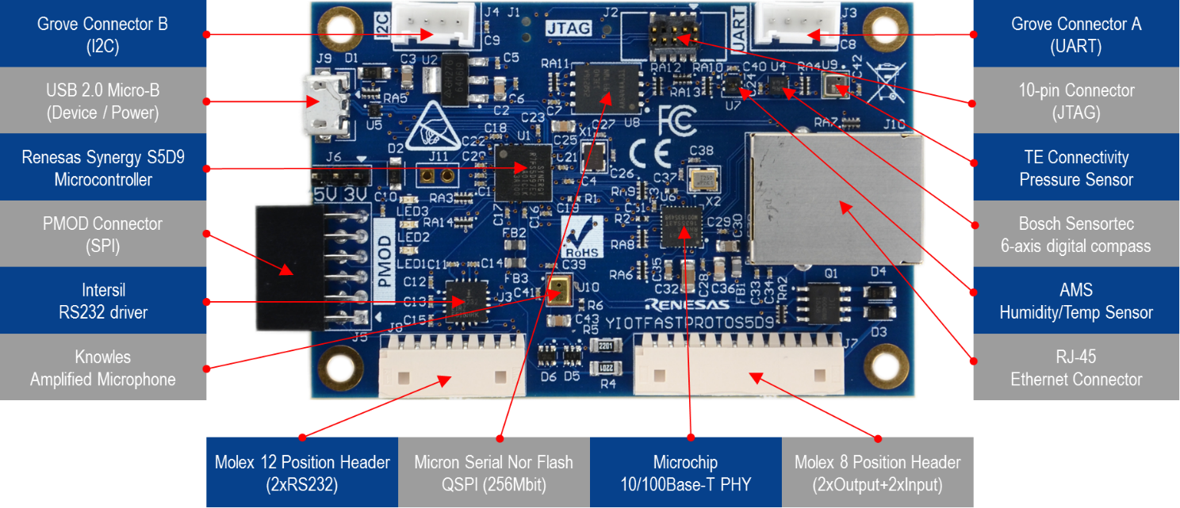

**Figure 3.2 S5D9 MCU board main components**

The MCU at the heart of the board is a Renesas Synergy S5D9 device. It is based on the ARM Cortex-M4F core running at 120 MHz. The CPU features a floating point unit and vector interrupt control unit. The MCU adds high-performance, zero wait-state flash and rich peripheral set that makes it suitable for a broad range of applications.

The 32 MB QSPI flash memory is Micron N25Q256A13EF840E. It can be used to store digital assets needed by the GUI design or even an executable code.

# Power Supply

The IoT Fast Prototyping Kit requires a single 5V power supply source. It can be provided through the USB Device connector J9 or through the Molex MicroBlade series connector J8.

**Error! Reference source not found.** shows the pin information for the power connectors, and **Error! Reference source not found.** shows the pin information for the USB connector.

Table 4.1 USB Device Connector (J9)

|  |  |
| --- | --- |
| Pin # | Function |
| 1 | +5VDC |
| 2 | Data - |
| 3 | Data + |
| 4 | USB ID |
| 5 | Ground |

Figure 4.1 LDO regulator used in the MCU board.

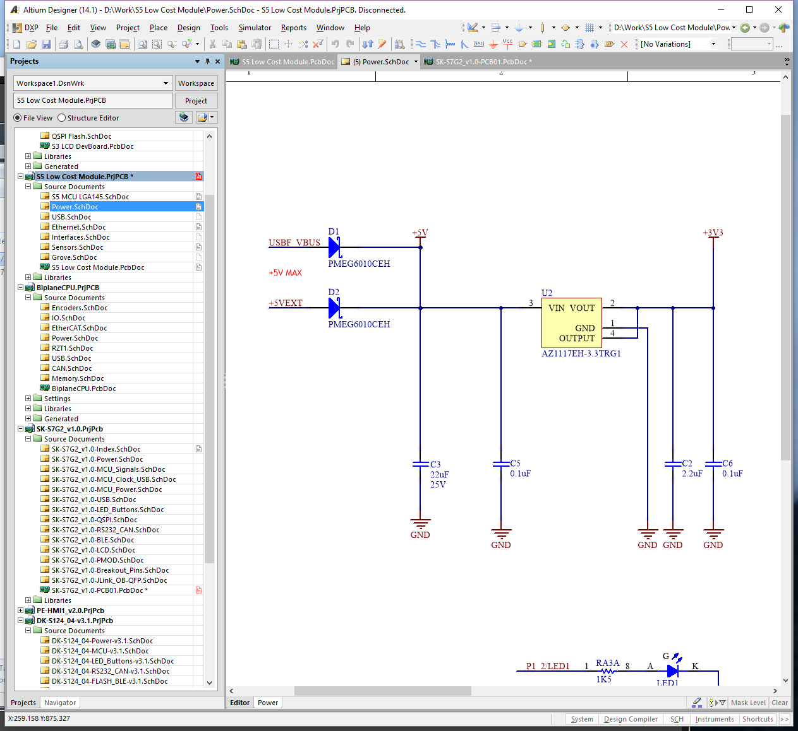

Figure 4.1 LDO regulators and boost converter in MCU board

# PMOD and Grove Connectors

The S5D9 MCU board offers one PMOD connector. It can interface with modules that require UART, I2C, or SPI interface. The function of the PMOD is dependent on the initialization and the pin-muxing of the MCU. The PMOD connector pin map is shown in Table 5.1.

Table 5.1 PMOD Connector

|  |  |
| --- | --- |
| Pin # | PMOD D |
| 1 | SSLB0/CTS9 – P2\_5 |
| 2 | MOSI/TXD9 – P2\_3 |
| 3 | MISO/RXD9 – P2\_2 |
| 4 | RSPCK/SCK9 – P2\_4 |
| 5 | GND |
| 6 | J6 defined 3.3/5V |
| 7 | GPIO – P7\_8/IRQ11 |
| 8 | GPIO – P2\_6/SSLB1\_A |
| 9 | GPIO – P2\_7/SSLB2\_A |
| 10 | GPIO – P8\_1 |
| 11 | GND |
| 12 | VCC (3.3V or 5V) |

The PMOD connector has a selectable power voltage provided by the J6 header. The jumper position for each voltage option is described in Table 5.2.

**Table 5.2 PMOD Voltage Selection (J6)**

|  |  |
| --- | --- |
| Pins | Selected Voltage |
| 1 - 2 | 3.3V |
| 2 - 3 | 5V |

The Grove connectors offer the following interfaces:

* UART interface (Grove A)
* I2C interface (Grove B)

The pin-mapping of the connectors is described in Table 5.3.

**Table 5.3 Grove Connectors**

|  |  |  |
| --- | --- | --- |
| Pins | Grove A  UART | Grove B  I2C |
| 1 | P4\_10/RXD0 | P1\_0/SCL1 |
| 2 | P4\_11/TXD0 | P1\_1/SDA1 |
| 3 | 3.3V | 3.3V |
| 4 | GND | GND |

Figure 5.1 and Figure 5.2 show schematics for the PMOD and Grove connectors, respectively.

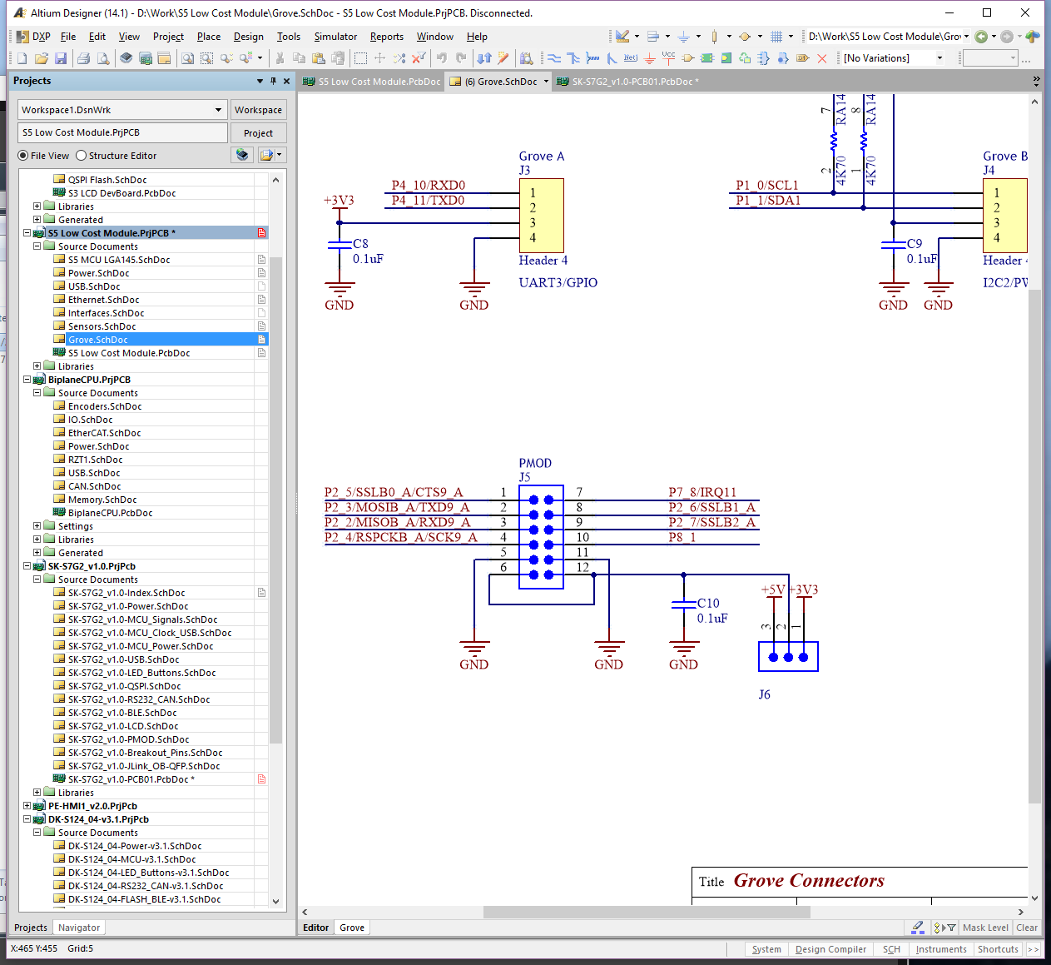

Figure 5.1 PMOD schematic

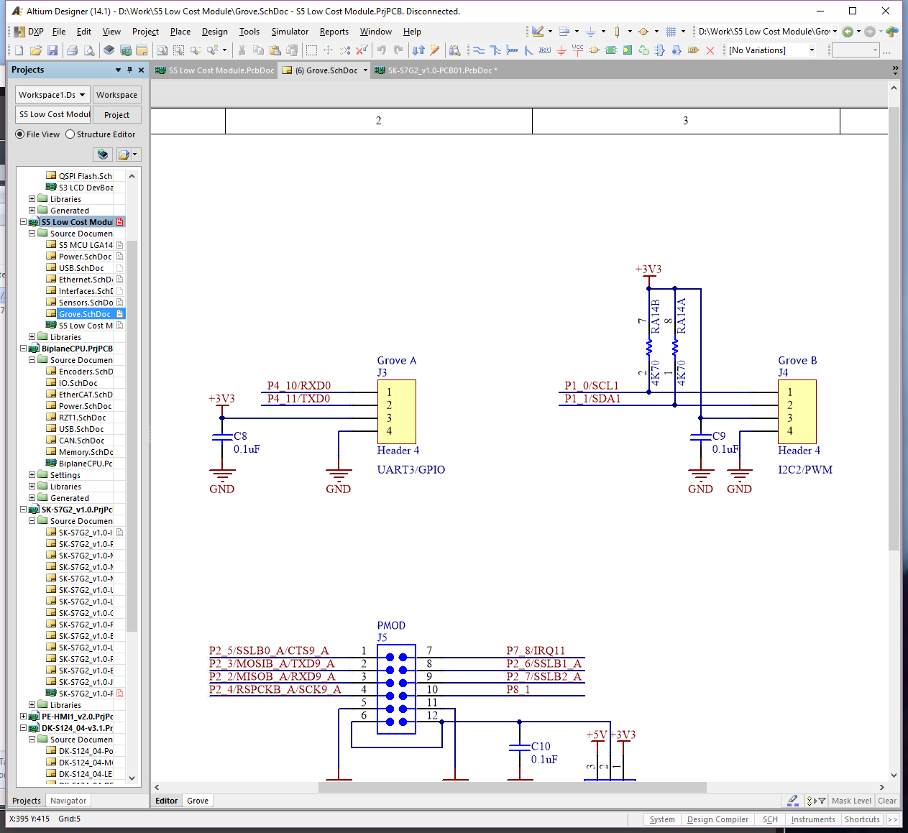

Figure 5.2 Grove connector schematic

# USB Interface

The S5D9 IoT Fast Prototyping kit provides USB device interface only. The wiring of the connector pins to the chip is shown in Table 6.1

Table 6.1 USB Micro B Type Receptacle - Device Mode (J9)

|  |  |  |
| --- | --- | --- |
| Pin Number | Function | Device Port/ Pin Number |
| 1 | Power 5V | USB VBUSIN |
| 2 | Data - | USB DM |
| 3 | Data + | USB DP |
| 4 | N.C. | |
| 5 | GND | GND |

Figure 6.1 describes the USB interface implementation:.

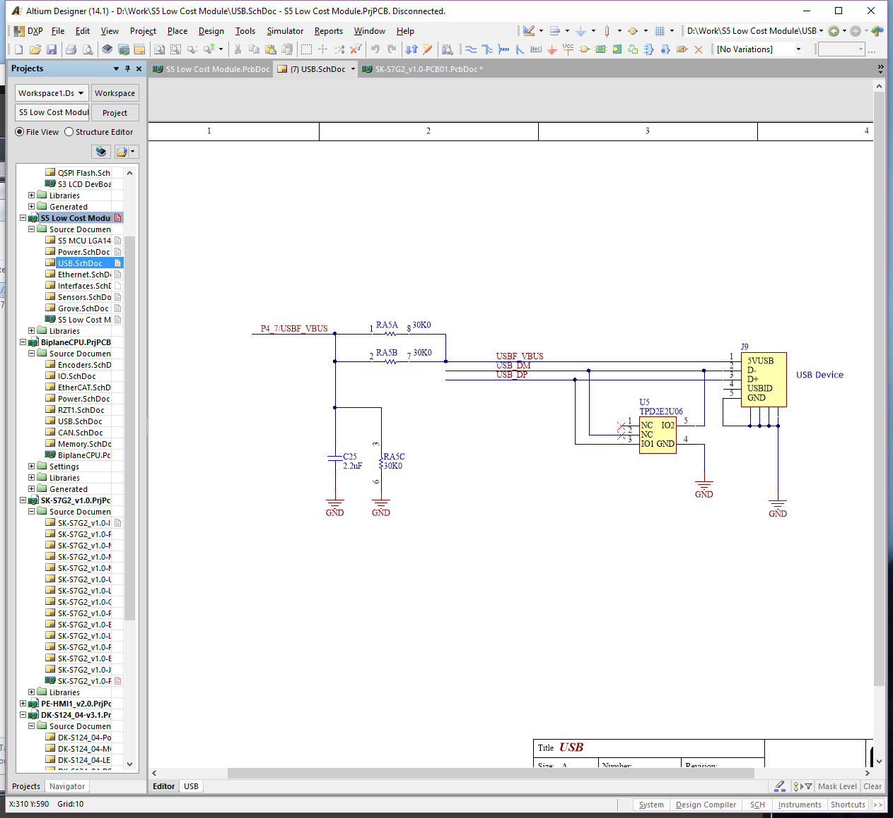

Figure 6.1 USB interface implementation

# Digital Inputs and Outputs

## 24V Tolerant Digital Inputs and Outputs

The S5D9 board includes 24V tolerant interface to digital inputs and features 1A rated MOSFETs suitable to drive inductive loads such as solenoids. The schematic below shows circuits related to these interfaces.

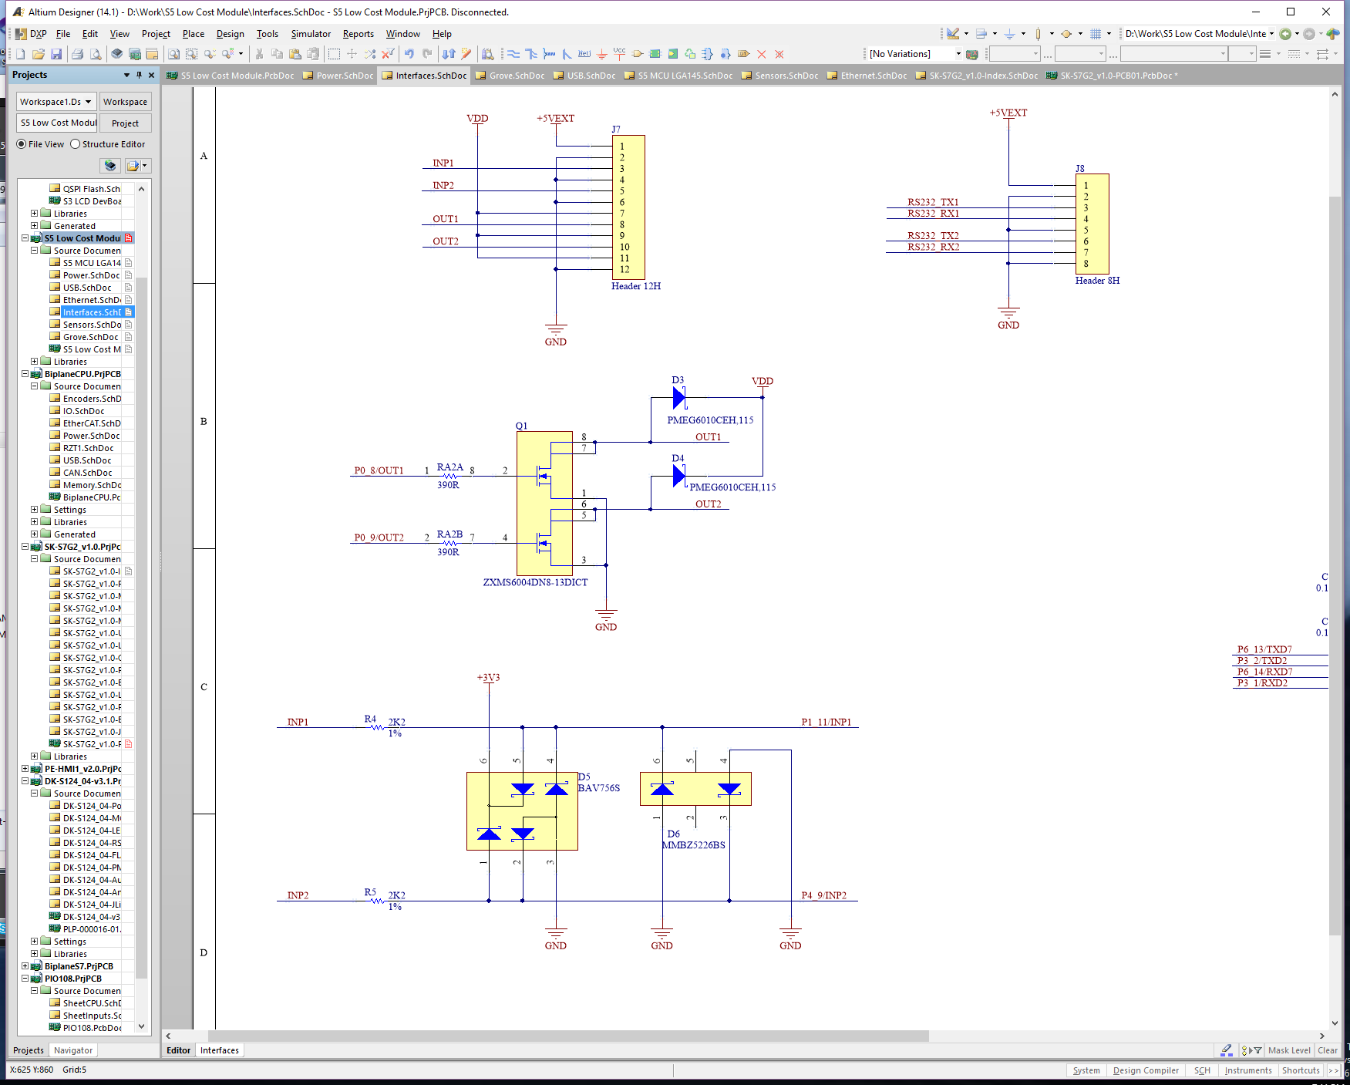

Figure 7.1 Digital Inputs and Outputs

The table below shows the mapping between the digital inputs, outputs and the matching MCU pins used for interfacing to them.

Table 7.1 24V Tolerant Digital Inputs and Outputs Mapping

|  |  |  |
| --- | --- | --- |
| Molex MicroBlade  **Connector J7** | Pin Type | MCU Port |
| 0 | Power +5V |  |
| 1 | Ground |  |
| 2 | Red |  |
| 3 | Input – INP1 | P1\_11 |
| 4 | Ground |  |
| 5 | Input – INP2 | P4\_9 |
| 6 | Ground |  |
| 7 | Power +24V |  |
| 8 | Output – OUT1 | P0\_8 |
| 9 | Power +24V |  |
| 10 | Output – OUT2 | P0\_9 |
| 11 | Power +24V |  |
| 12 | Ground |  |

The PMOD and Grove connectors also provide interface to the MCU ports that can be configured as digital inputs or outputs. They are 5V tolerant, so no level shifters are required when interfacing to 5V powered peripherals.

## On-Board LEDs

The S5D9 board provides 3 on-board LEDs for user-defined functions. They are connected to general purpose output pins through a single resistor. The output active state is 1. When set, it turns the LED on. Table 7.2 describes the mapping between the LEDs and the ports that drive them.

Table 7.2 User Defined LED Mapping

|  |  |  |  |
| --- | --- | --- | --- |
| LED# | Color | Designator | Device Port/Pin |
| 0 | Green | LED1 | P1\_2 |
| 1 | Yellow | LED2 | P1\_3 |
| 2 | Red | LED3 | P1\_13 |

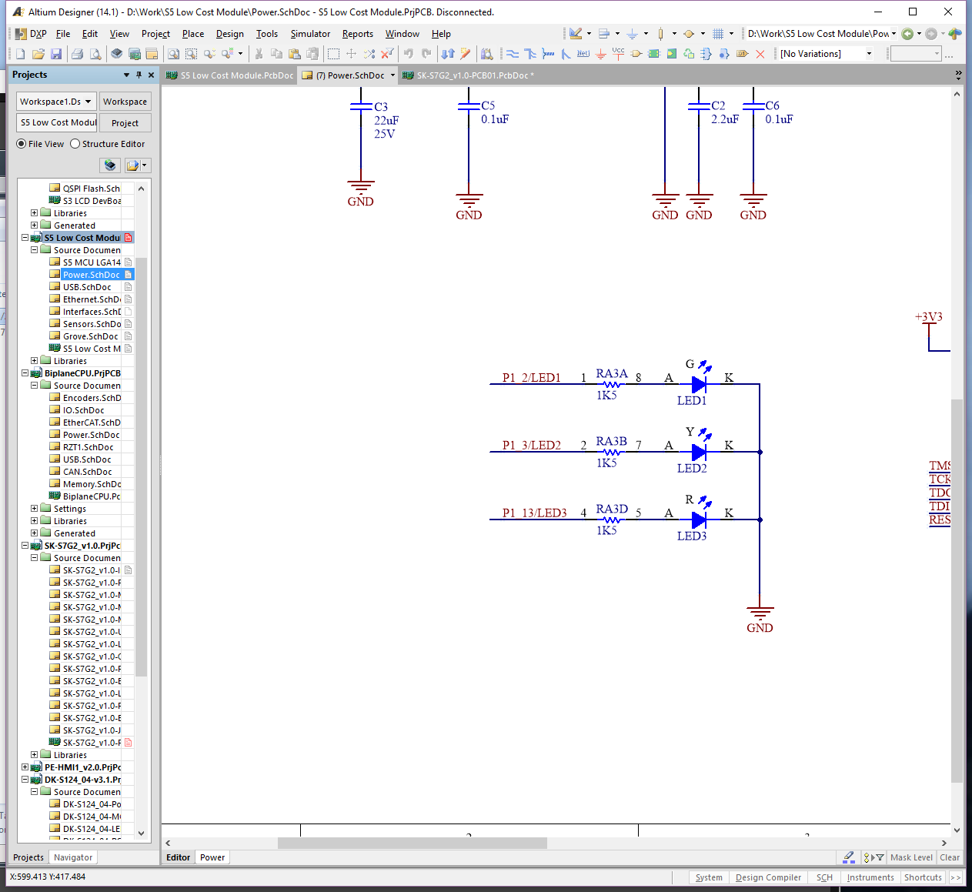

Figure 7.2 Mapping between LEDs, ports

# Dual RS232 Interface

The S5D9 board provides dual RS232 interface transceiver. The serial interfaces are available on connector J8. The pin mapping of the connector to the MCU ports is described in the table below:

Table 8.1 Dual RS232 Interface

|  |  |  |
| --- | --- | --- |
| Molex MicroBlade  **Connector J7** | Pin Type | MCU Port |
| 1 | Power +5V |  |
| 2 | Ground |  |
| 3 | TX1 | P3\_2/TXD2 |
| 4 | RX1 | P3\_1/RXD2 |
| 5 | Ground |  |
| 6 | TX2 | P6\_13/TXD7 |
| 7 | RX2 | P6\_14/RXD7 |
| 8 | Ground |  |

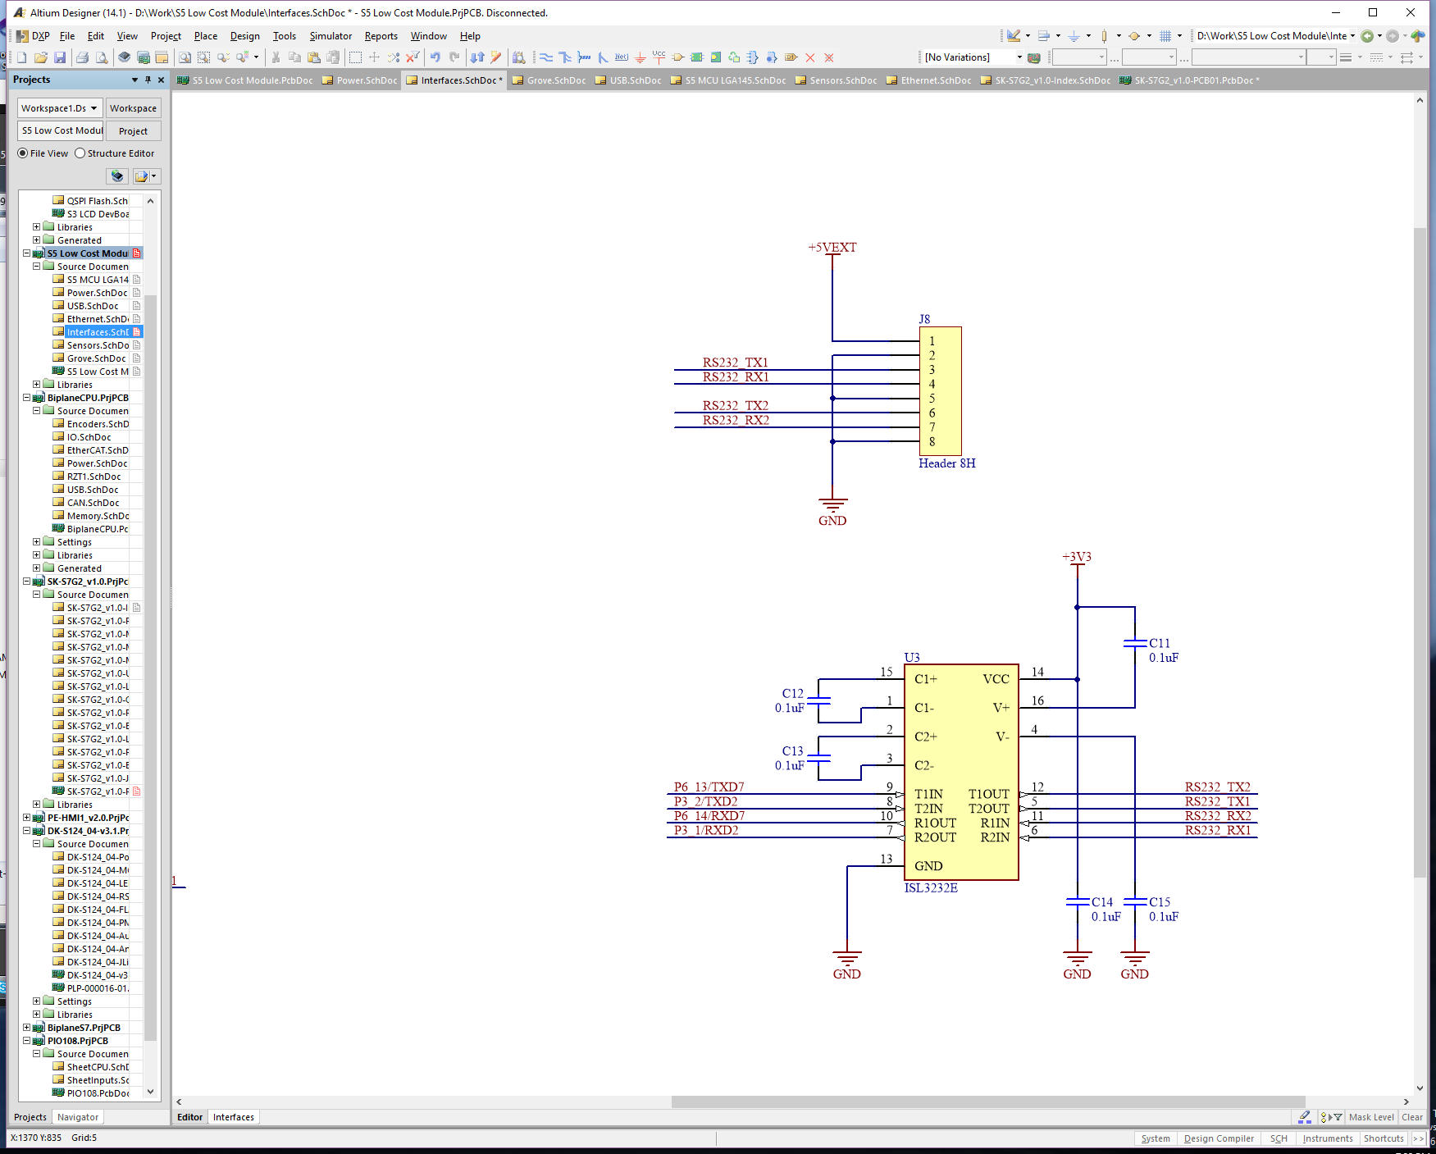

Figure 8.1 Dual RS232 Ports

# JTAG Probe Interface

The JTAG probe interface is provided on the connector J2. The connector part number is Samtec FTSH-105-01-L-DV-007-K.

Table 9.1 JTAG Probe Interface - Connector J2

|  |  |  |  |  |  |
| --- | --- | --- | --- | --- | --- |
| Pin# | Direction | Description | Pin# | Direction | Description |
| 1 |  | Power 3V3 | 2 | Input | TMS |
| 3 |  | GND | 4 | Input | TCK |
| 5 |  | GND | 6 | Output | TDO |
| 7 |  | N.C | 8 | Input | TDI |
| 9 |  | GND | 10 | Input | RESET |

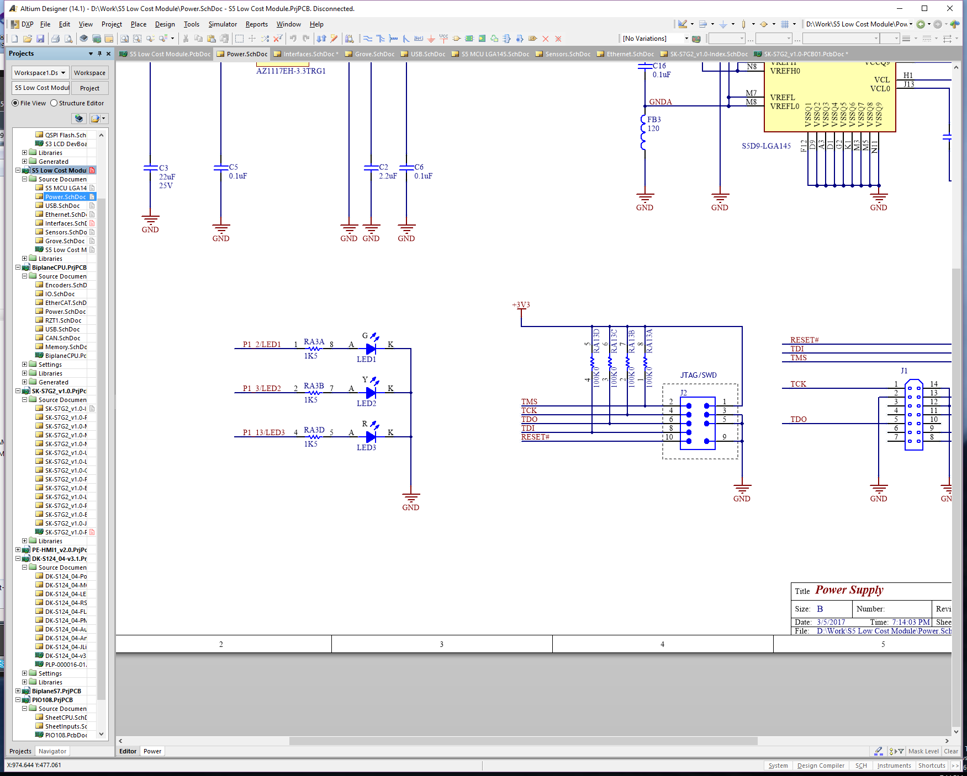

Figure 9.1 JTAG probe interface connections

Alternatively, the JTAG interface is available on the connector J1 – designed to be used with Tag Connect 14-pin probe. The probe part number is Tag Connect XXXXXXX.

Table 9.2 JTAG Probe Interface - Connector J1

|  |  |  |  |  |  |
| --- | --- | --- | --- | --- | --- |
| Pin# | Type | Description | Pin# | Type | Description |
| 1 | Input | TCK | 14 | Power | Ground |
| 2 | Power | Ground | 13 | Input | RESET |
| 3 | N.C. |  | 12 | Power | Ground |
| 4 | N.C. |  | 11 | Input | TDI |
| 5 | Output | TDO | 10 | N.C. |  |
| 6 | N.C. |  | 9 | Input | TMS |
| 7 | N.C. |  | 8 | Power | +3V3 |

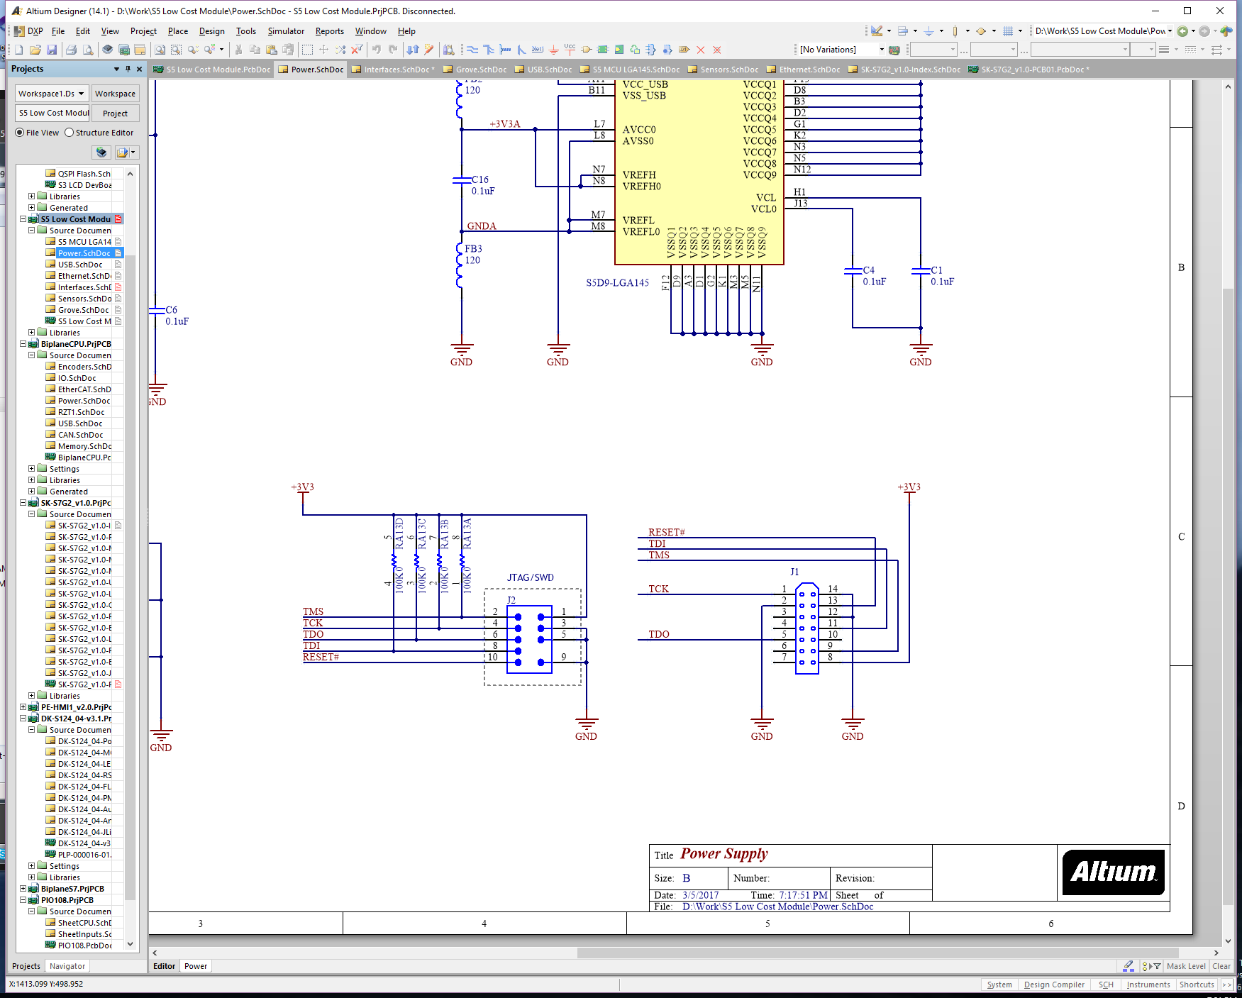

Figure 9.2 JTAG probe interface connections

**Revision History**

|  |  |  |  |
| --- | --- | --- | --- |
| Rev. | Date | Description | |
| Page | Summary |
| 1.00 | March 3, 2017 | - | Initial version |

All trademarks and registered trademarks are the property of their respective owners.

|  |
| --- |
| IoT Fast Prototyping Kit S5D9 User’s Manual  Publication Date: Rev.1.00 March 3, 2017  Published by: Renesas Electronics Corporation |



e_address_notice

R12UMxxxxEU0100

Renesas Synergy™ Platform

IoT Fast Prototyping Kit S5D9 User's Manual